Name: _______________________ CWID: _______________________

**Pre-Lab**: Reverse transcription is the process by which RNA is converted into DNA. The most common adapter for reverse transcription is an oligo-DT primer, which binds to polyA tails. Should you expect to detect mitochondrial RNA (mtRNA), meaning that it is transcribed from the mitochondrial genome?

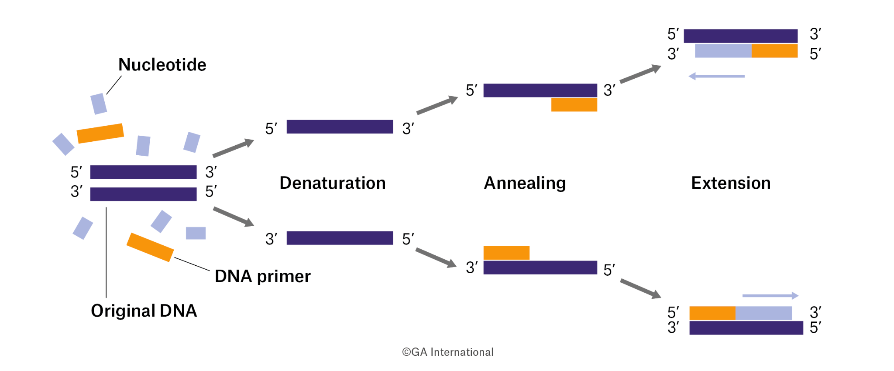

Polymerase chain reaction describes the amplification of a single product based on specific / unique DNA primers. How many base-pairs do you need to define a ‘unique’ primer? What is the statistical reason for this definition?

A common polymerase for PCR the Taq polymerase, provided as a master-mix kit as described below by Promega:

GoTaq® Green Master Mix, 2X: GoTaq® DNA Polymerase is supplied in 2X Green GoTaq® Reaction Buffer (pH 8.5), 400μM dATP, 400μM dGTP, 400μM dCTP, 400μM dTTP and 3mM MgCl2. Green GoTaq® Reaction Buffer is a proprietary buffer containing a compound that increases sample density, and yellow and blue dyes, which function as loading dyes when reaction products are analyzed by agarose gel electrophoresis. The blue dye migrates at the same rate as 3–5kb DNA fragments, and the yellow dye migrates at a rate faster than primers (<50bp), in a 1% agarose gel.

1.] Write out all of the components below as ingredients.

2.] Describe the purpose of each component in the mixture.

3.] Describe why we utilize a Taq polymerase instead of a native human polymerase, based on your understanding of PCR.

4.] Describe when and why we utilize a ‘master-mix.’

Q1: What is the size of the blue band in the gel?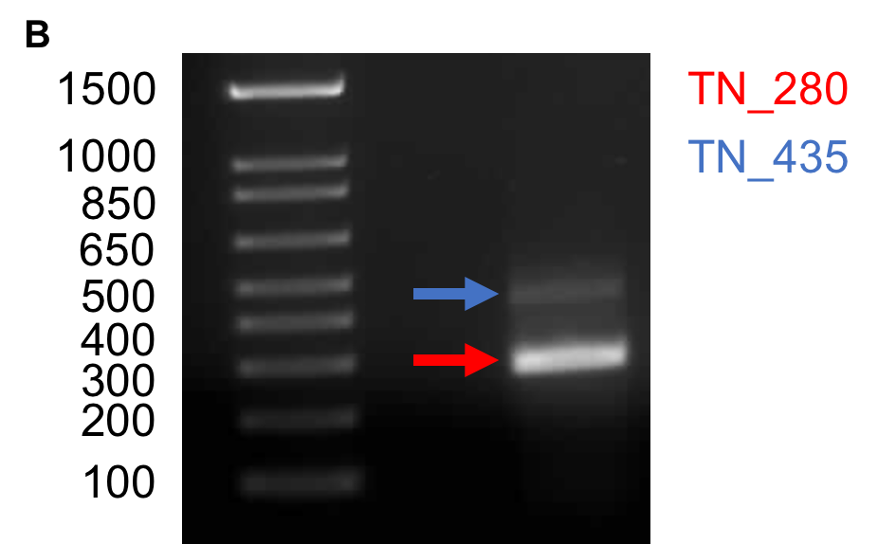

Q2: What is the size of the red band in the gel?

Q3:

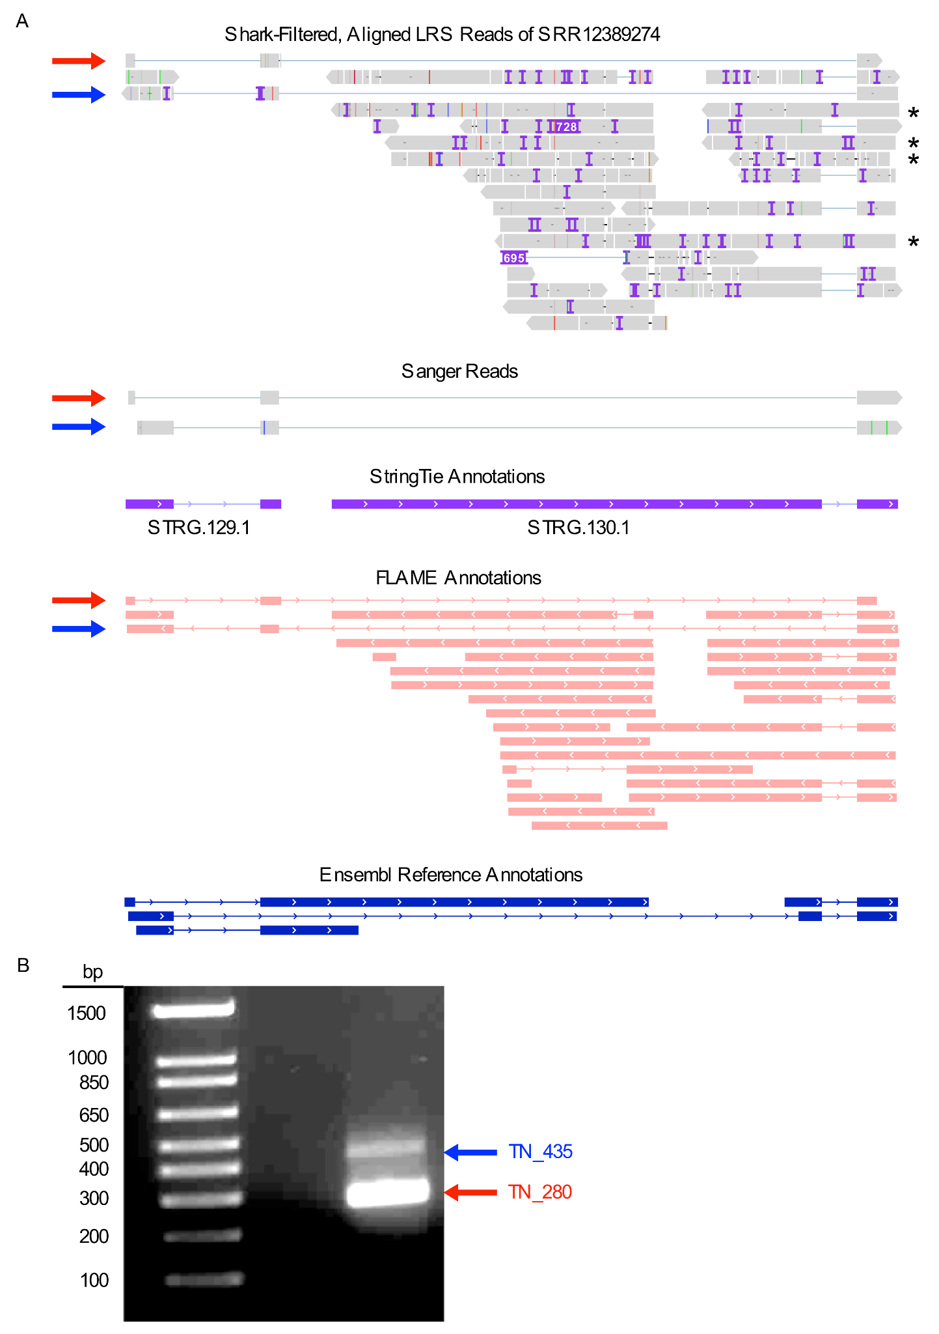



What makes the blue Sanger read novel compared to the reference annotation?

What makes the red Sanger read novel compared to the reference annotation?

Describe how this relates to size selection in sequencing processes:

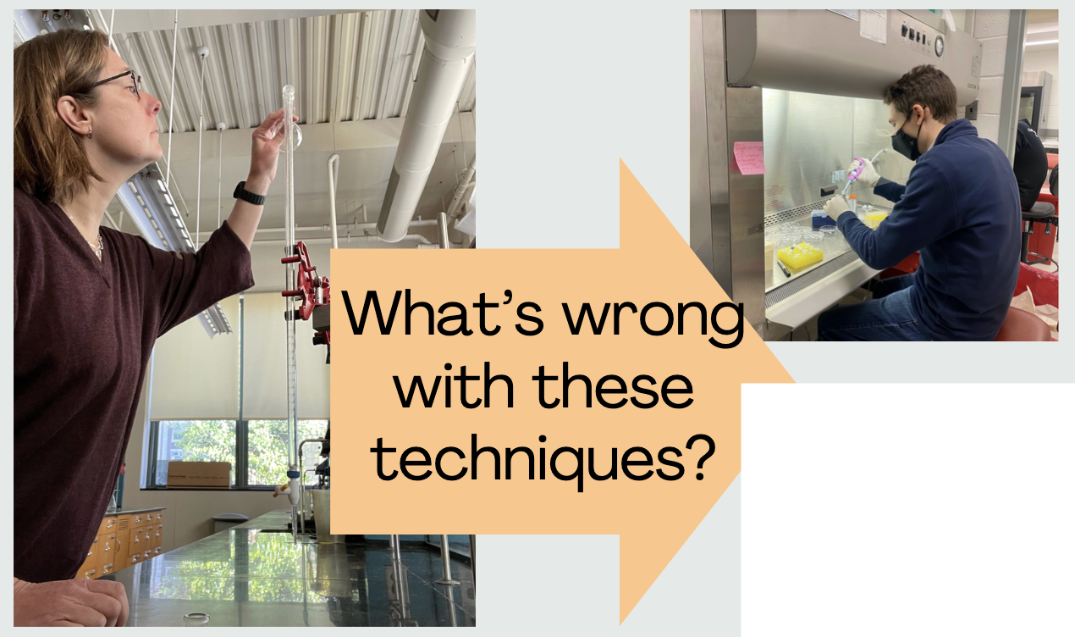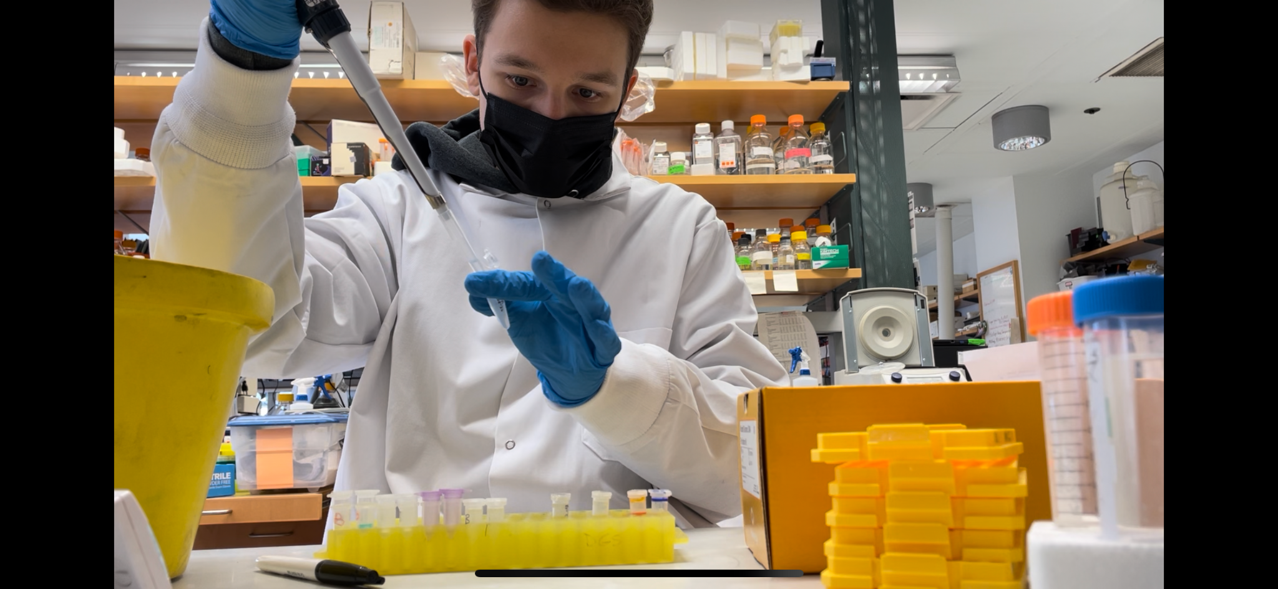

What’s wrong with these lab techniques?

1.] How does soap clean grease?

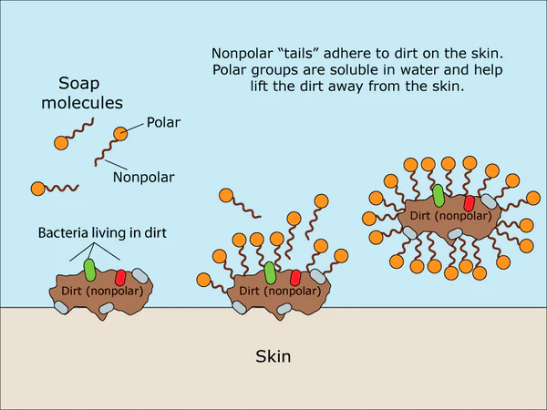

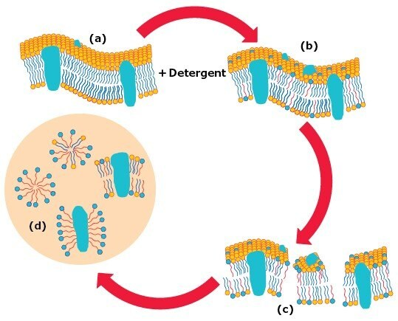

2.] How does this relate to processes occurring with plasma membranes?

3.] Why does digitonin disrupt plasma membranes? 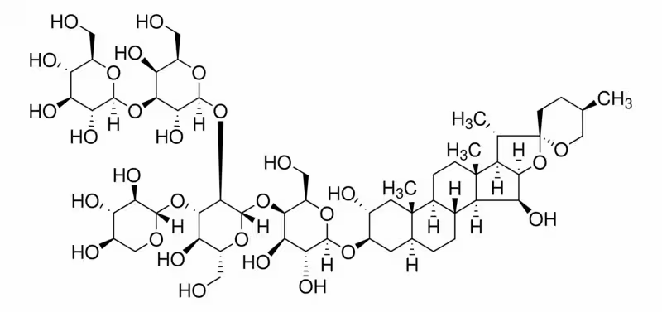

4.] How could we utilize digitonin to isolate mitochondria from cells? What other techniques could we potentially employ?

5.] If we were to isolate extracellular mitochondria within blood plasma, which steps can we skip from the initial protocol?

INITIAL PROTOCOL

All the steps were performed on ice.  
 1. Count and harvest cells (1 × 106 to 1 × 108 cells per sample) by trypsinization. Cells were counted using the InvitrogenTM CountessTM Automated Cell Counter.  
 2. Wash cells with 1X PBS and pellet at 215 × **g**, 5 min at 4 °C.  
 3. Resuspend pelleted cells in 500 μl of STM buffer with RNASE inhibitor and incubate on ice for 5 min.  
 4. For cell lysis, add 50 μl of 0.2 % high purity digitonin to achieve a final concentration of 0.02%. Vortex vigorously (5–10 s) every minute for 5 min.  
 5. Add 1:1 volume (500 μl) of STM buffer with RNASE inhibitor to the samples and centrifuge immediately in a benchtop microfuge at 700 × **g** for 10 min at 4 °C to remove unbroken cells and cell debris.  
 6. Carefully transfer the supernatant to a new tube and centrifuge at 10,000 × **g** for 15 min at 4 °C. Remove the supernatant (cytoplasmic fraction).

OPTIONAL: Add RNASE A, diluted in 50 μl STM buffer, at 100 U/μl. Incubate at room temperature for five minutes. RNASE A Prep: RNase A, DNase and protease-free (10 mg/mL), dilute 1 μl in 99 μl of STM buffer

7. For washing the mitochondria-containing pellet, add 500 μl of 1x STM buffer with RNASE inhibitor on top of the pellet. Do not resuspend; instead, invert the position of the pellet in the centrifuge and spin at 10,000 × **g** for 5 min at 4 °C.  
 8. Aspirate the supernatant completely and store the mitochondria-containing pellet at -80 °C until further use.

There are many considerations and protocols to keep in mind during RNA isolation.

**RNAseAway purpose & function**

* Removes RNase contamination from labware (glassware and plasticware)
* Spray like disinfectant spray then wash with distilled water!

When should you use RNAseAway during your procedure?

**Qiagen RNAeasy kit**

* Cells! Buffer RLT (350μl for dish <6cm / 600μl for 6-10cm)
* Add 1 volume of 70% Ethanol (pipette to mix), then transfer up to 700μl to the RNeasy Mini Spin column. Centrifuge for ~15 seconds (speed of ≥8000 x g).
  + Discard flow-through
  + DNase Digestion Happens Here
* Add 700 μl Buffer RW1 to the RNeasy spin column. centrifuge for 15 s at the same speed. Discard the flow-through.
* Add 500 μl Buffer RPE to the RNeasy spin column. centrifuge for 15s at same speed. Discard the flow-through.
* Add 500 μl Buffer RPE to the spin column. Centrifuge for 2 min at same speed.
* Place the RNeasy spin column in a new 1.5 ml collection tube (supplied). Add 30–50 μl RNase-free water directly to the spin column membrane. Centrifuge for 1 min at same speed to elute the RNA.
* If the expected RNA yield is >30 μg, repeat the previous using another 30–50 μl of RNase-free water or using the eluate from the previous step (if high RNA concentration is required). Reuse the collection tube from step 7.

DNase Digestíon

* DNase I stock solution by injecting 550 µl RNase-free water into the DNase I vial using an RNase-free needle and syringe.
* Mix gently by inverting the vial. NO VORTEX
* Add 350 µl Buffer RW1 to the RNeasy column centrifuge for 15 s at ≥8000 x g (≥10,000 rpm). Discard flow-through.
* Add 10 µl DNase I stock solution to 70 µl Buffer RDD. Mix by gently inverting the tube. Centrifuge briefly (<5s presumably)
* Add DNase I incubation mix (80 µl) directly to RNeasy column membrane, and place on the benchtop (20–30°C) for 15 min.
* Add 350 µl Buffer RW1 to the RNeasy column and centrifuge for 15 s at same speed. Discard flow-through. Continue with the next step of the RNAeasy kit.

Why should you not vortex the DNAse vial?

What is the purpose of the DNAse digestion step?

Qubit Invitrogen RNA Concentration Protocol

* This protocol assumes that we are preparing standards for calibrating the Qubit Fluorometer ( Components C and D) .

1. Set up the required number of Qubit tube for standards ( C and D) and samples.

* Use only thin-wall, clear 0.5-mL PCR tubes for the Qubit 4
* Use only 8 x 200 - microL tube strips for Qubit flex

1. Label the tube lids
2. Prepare the Qubit working solution by diluting the Qubit RNA HS reagent 1:200 in qubit RNA HS buffer. Use clean plastic tube each time you prepare QUBIT working solution

* For each sample we will need 199 microL of dilution buffer ( Make sure to include enough for excess and for the two standards
* Add 200x fluorometric reagent. 1 microL for each standard and the 2 standards.

1. Add Qubit solutions to each tube such that the final volume is 200 microL.

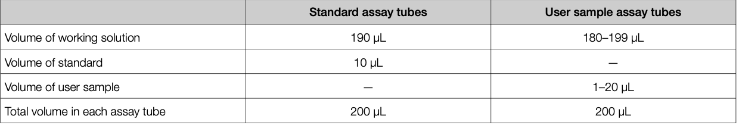

1. Add 190 microL of the working solution to standards 1 and 2
2. Add between 180 and 199 microL of working solution to each sample (depends of dilution)
3. Add 10 microL of each Qubit standard to the appropriate standard tubes
4. Add 1-20 microL of each user sample to the appropriate tube (Depends on the anticipated concentration)
5. Vigorously vortex for 3-5 seconds
6. Allow tube to incubate at room temperature for 2 minutes, then proceed to read standards and samples

What should be the amount of sample that is added to this protocol?

What is the principle behind the Fluorometer?

Why do we need standards?

Agilent Tapestation Protocol:

1. Allow reagents to equilibrate at room temp for 30 min
2. Vortex mix before use
3. Thaw total RNA samples on ice
4. Prepare sample by mixing 5uL RNA sample buffer with 1 uL RNA sample
   1. For best results, use reverse pipetting technique
5. Spin down, then vortex using IKA vortexer and adaptor at 2000 rpm for 1 min
6. Spin down to position the sample at the button of the tube
7. Sample denaturation
   1. Heat sample at 72 C (162 F) for 3 min
   2. Place samples on ice for 2 min
   3. Spin down to position the sample at the bottom of the tube

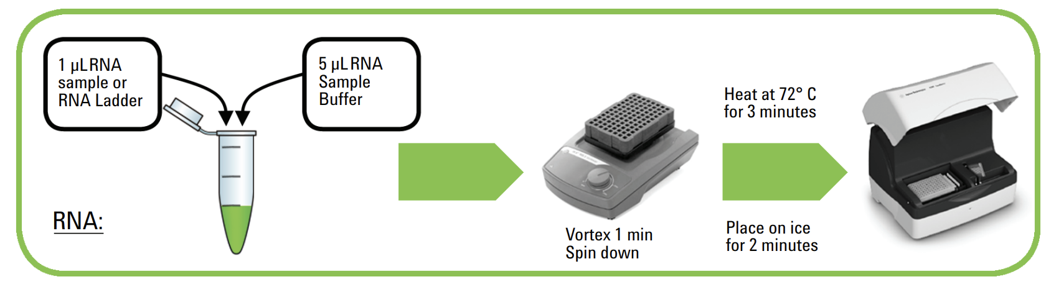

What is the purpose of vortexing the mix?

Why is the sample heated at 72˚C for 3 minutes before the protocol?

What is the purpose thereafter of placing the samples on ice for 2 minutes?

Describe in your own words the reverse pipetting technique:

What is the function of the IKA vortexer and adaptor?

The following is a spectrum graph for purified nucleic acids, e.g. DNA and RNA.

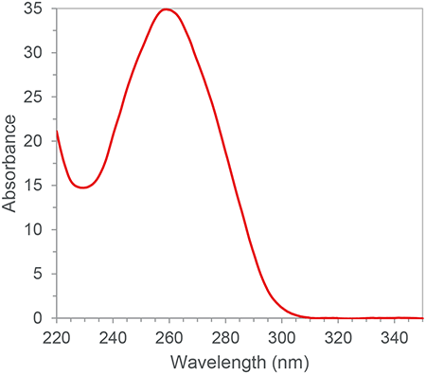

a.) Please identify the λmax for DNA/RNA:

b.) For these kinds of purified nucleic acids the absorbance at 280 nm often represents the amount of protein content, while the absorbance at 320 nm can represent general background noise in the solution. Calculate the approximate ratio between protein content and nucleic acid content:

***Assume for the remaining questions that the calculated ratio indicates an adequate nucleic acid purification***

There is a mysterious tube in the lab. You measure the absorbance on a spectrophotometer, with the machine providing the “raw” values in the table below.

| sample | 260 Raw | 280 Raw | 320 Raw | 260 | 280 | 260/280 | ng/µl |
| --- | --- | --- | --- | --- | --- | --- | --- |
| blank | .072 | .069 | .060 | n/a | n/a | n/a | n/a |
| tube | .084 | .075 | .061 | ? | ? | ? | ? |

Recall that the 320 nm signal is general background noise - which allows you to ensure that samples have the same amount of background signal. The amount of nucleic acid/protein material should be calculated in relation to the amount absorbed by a tube with the liquid which the nucleic acid is dissolved in (blank).

a.) Calculate the amount of the 260 and 280 nm signal attributed to the nucleic acids in the tube?

b.) Is this an “adequate nucleic acid purification,” when comparing the 260/280 ratio to the optimal ratio as calculated in **1-b**?

The Beer-Lambert Law is a relationship between absorbance and concentration: A = εlc. If A = absorbance of nucleic acids, εDNA = 0.020 (μg/mL)-1cm-1 and I = path length. You have been provided a diagram of the equipment you utilized to make these measurements.

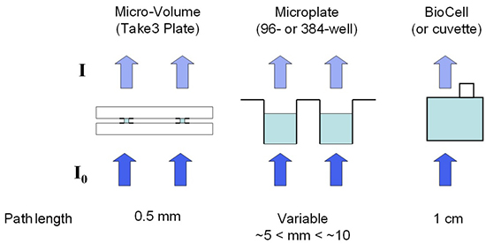

a.) Calculate the concentration of nucleic acids in this tube:

After completing your experiment on the spectrophotometer, you have 25 µl left in the mystery tube. The label states: “LINC00173 // DNA // 3092 bases.” You assume that this means the tube contains identical particles of DNA 3092 bases long called LINC00173.

Each base is on average 650 g/mol. You wish to phosphorylate the 5’ ends of the DNA strands; each DNA strand has one 5’ end. You will design a reaction totaling 50 µl to accomplish this task. You have been provided the following instructions:

* 10 units (or 1 µl) of T4 PNK-enzyme can phosphorylate 300 pmol of 5´ termini
* You should have a final concentration of 1X T4 PNK Buffer
* You should have a final concentration of 1 mM ATP
* Nuclease-free water is not involved in the reaction; it is simply to ensure that the final reaction volume is 50 µl.

You have access to the reagents described in the following table:

| T4 PNK | ? |
| --- | --- |
| 10X T4 PNK Buffer | ? |
| 10 mM ATP | ? |
| DNA | ? |
| Nuclease-free Water | ? |

Calculate all the necessary volumes to perform a successful phosphorylation reaction: